American International University-Bangladesh (AIUB)

Department of Computer Science

Faculty of Science & Technology (FST)

PROJECT TITLE: **Pet Mart Management System**

A Software Engineering Project Submitted By

|  |  |  |  |  |
| --- | --- | --- | --- | --- |
| Semester: Summer 22-23 | | Section: | Group Number: 04 |  |
| SN | Student Name | Student ID | Contribution (CO1+C03) | Individual Marks |
| 01 | MD Ridwan Hossain Rafin | 21-45175-2 |  |  |
| 02 | Ajmayeen Chisty | 21-45331-2 |  |  |
| 03 | Nafisa Sharmin Sadia | 21-45162-2 |  |  |
| 04 | Mohammed Anisur Rahman | 15-30739-3 |  |  |

**Description of Student's Contribution to the Project Work**

|  |
| --- |
| Student Name: MD Ridwan Hossain Rafin  Student ID: 21-45175-2  Contribution in Percentage (%): **30%**  **Contribution to the Project:**  **Problem Analysis**  **System Design Specification (State)**  **Requirement Analysis**  **WBS and Effort Estimation**    Signature of the Student |
| Student Name: Ajmayeen Chisty  Student ID: 21-45331-2  Contribution in Percentage (%): **30%**  **Contribution to the Project:**  **Project Proposal**  **UI/UX Design**  **System Design Specification (Use Case)**  **Project Test Planning**  **Risk Analysis**    Signature of the Student |
| Student Name: Nafisa Sharmin Sadia  Student ID: 21-45162-2  Contribution in Percentage (%): **25%**  **Contribution to the Project:**  **System Design Specification (Sequence)**  **Requirement Analysis**  **Project Test Planning**  **Activity Scheduling and Resource Allocation**    Signature of the Student |
| Student Name: Mohammed Anisur Rahman  Student ID: 15-30739-3  Contribution in Percentage (%): **15%**  **Contribution to the Project:**  **Model Selection**  **System Design Specification (Activity)**  **Progress of Project Execution**    Signature of the Student |

**Title: Pet Mart Management System**

**EXERCISE EXERCISE-1: Problem Analysis:**

**Description:**

ThePet Mart Management Project is an innovative software solution designed to streamline and optimize the operations of a pet store or pet mart. It aims to provide an efficient and user-friendly platform for managing various aspects of the pet mart business, including inventory management, customer relations, sales, and financial transactions.

The project offers a comprehensive set of features that caters to the unique requirements of a pet mart. One of the primary functionalities is inventory management, which allows pet mart owners and employees to effortlessly track and manage their inventory of pet food, accessories, toys, and other products. The system enables users to easily add new products, update existing stock, and receive notifications for low stock levels to ensure timely reordering.

In addition to inventory management, the Pet Mart Management Project includes a customer relationship management (CRM) module. This module enables pet mart staff to maintain a comprehensive database of customer information, including contact details, purchase history, and preferences. By having access to this data, employees can provide personalized recommendations and improve customer satisfaction by tailoring their services to individual needs.

The project also incorporates a point-of-sale (POS) system that simplifies the sales process. This feature allows staff to quickly process transactions, generate invoices, and manage various payment methods, such as cash, credit cards, or mobile payments. The system can also handle returns and exchanges, ensuring a seamless customer experience.

Financial management is another crucial aspect of the Pet Mart Management Project. The software provides tools for tracking sales, calculating revenue, and generating financial reports. These reports offer valuable insights into the pet mart's performance, helping owners make informed business decisions and identify areas for improvement.

Moreover, the Pet Mart Management Project offers integration with online platforms and marketplaces. This integration enables pet marts to expand their reach and sell products through e-commerce channels, thereby increasing their customer base and revenue potential.

The project is built with a user-friendly interface that requires minimal training and technical expertise. It can be accessed via desktop computers, tablets, or mobile devices, ensuring flexibility and convenience for the pet mart's staff.

In summary, the Pet Mart Management Project is a comprehensive software solution designed to enhance the efficiency, organization, and profitability of pet marts. By automating and streamlining various processes, such as inventory management, customer relations, sales, and financial transactions, the project empowers pet mart owners and staff to focus on delivering exceptional pet care services and building lasting customer relationships.

**Features:**

**Pet Listings and Adoption:**

1. Pet listings for dogs, cats, birds, and small animals are available for users to peruse.

2. Both breeders and pet owners may make profiles and post ads for their animals' adoption or sale.

3. Pet adoption businesses and rescue groups can advertise available animals and oversee the adoption procedure.

**Online Store:**

1. Users may purchase pet-related things including food, toys, accessories, and healthcare supplies through a fully integrated e-commerce platform.

2. Customers may make safe online purchases, read reviews, and compare pricing.

**Pet Services:**

1. Pet service providers may set up profiles and advertise their services, including groomers, trainers, vets, and boarding facilities.

2. Using search criteria such as location, availability, and client reviews, users may find and schedule appointments with these service providers.

**Counseling:**

1. Behavioral Issues: Veterinary counseling aids pet owners in resolving issues with their animals' behavior. Aggression, anxiety, phobias, separation anxiety, destructive behavior, excessive barking, litter box difficulties, and other disorders might fall under this category.

2. Training and Socialization: Advice on socialization and training for pets is frequently included in counseling sessions. This may entail demonstrating fundamental obedience instructions, proper leash conduct, housebreaking, and methods for dealing with behavioral issues. Advice on socialization enables pet owners to expose their animals in a good and regulated way to new situations, people, and animals.

3. Health and Wellness Education: Veterinarian counselors may also impart knowledge on basic pet health and wellness issues in addition to offering behavioral and emotional assistance. Information about diet, exercise, preventative care, parasite management, and other elements that contribute to a pet's general well-being can be included in this.

**Pet Health Records and Reminders:**

1. Users may keep digital health records for their dogs, which provide information about past vaccinations, current medications, and planned visits.

2. Users may be proactive in preserving the health of their dogs by receiving automated reminders for vaccines, checkups, and other pet care activities.

**Transactions and Privacy:**

1. The system guarantees secure transactions and safeguards user data, including payment information.

2. Privacy options provide users the ability to block access to certain information and manage the visibility of their profiles.

**#Benefits:**

1. One-stop shop: Convenient platform for purchasing, selling, and managing pet-related operations.

2. Searching and Filtering: More effective user experience thanks to sophisticated search and filtering tools.

3. Healthcare: Digital records and reminders for better pet care and health management.

**Problem:**

**Root causes:** Roots of pet mart:

A few other causes that might have added to PetSmart's difficulties over time include:

1. Competition: Over the years, Petco, other pet retail shops, Chewy, and Amazon online have all presented severe competition to PetSmart.

2. Shifting customer preferences: Pet owners may pick different products and services when their lifestyles and tastes change, which would lead to a decline in sales at PetSmart.

3. Economical factors: Consumer reluctance to spend money on luxuries like pet supplies and services might lead to a reduction in income.

4. Management decisions: Making bad management decisions, including expanding too rapidly or mismanaging funds, might cause the business to run into financial difficulties.

5. Concerns over animal welfare: PetSmart has faced criticism and legal action over allegations that animals under its care have been abused, which might damage the company's brand and turn away consumers.

**The main problem of pet mart:**

1. Increased competition: Due to the growth of online retailers and other brick-and-mortar pet businesses, Pet Mart is now facing increased competition in the market.

2. diminishing sales: Due to increased competition and changed consumer tastes, Pet Mart may be experiencing diminishing sales.

3. Price pressure: As internet retailers have proliferated, Pet Mart may find it difficult to compete on price while maintaining the quality of its products and customer service.

4. Disturbances in the supply chain: Pet Mart may be encountering issues with the supply chain, such as difficulty obtaining products, shipping delays, or disarrays in their distribution network.

5. Operational problems: Pet Mart can have operational problems with inventory management, personnel, and store maintenance.

6. Brand perception: Negative brand impression may result from inadequate products or poor customer service, which may affect all sales.

**Project Objectives:**  
  
1. To create a platform that will link people to several pet stores and veterinarians.

2. Possibility for consumers to use the platform to immediately make purchases or payments and compare the cost and availability of goods and services.

3. Making the platform user-friendly so that consumers can access the system from any device and making the platform user-friendly so that filtering based on preferences is made easier.

4. Customers can rate and evaluate the goods and services they have used to benefit other customers. Additionally, it will motivate stores and veterinarians to attempt to provide better services.

**Importance of pet mart:**

Pet Mart is significant for several reasons.

1. Pet Mart offers a comprehensive range of pet goods, including food, toys, grooming equipment, and medical supplies. As a result, pet owners can easily find everything they require for their animals in one location.

2. Pet services: Animal grooming, training, and medical care are just a few of the services offered by Pet Mart. This is useful for pet owners who want to provide the finest care for their animals while reducing the need to travel to various locations.

3. Adoption: PetSmart partners with animal welfare groups to provide adoption services to aid animals in need of homes. In addition to giving people a safe and useful place to adopt pets, this saves the lives of animals in need.

4. Education: PetSmart provides pet owners with instructional tools that include information on canine food, behavior, and health. This facilitates decision-making and helps pet owners to provide the best care for their animals.

5. Community involvement: PetSmart supports local communities through a range of programs, including donations to animal welfare groups, volunteer labor, and educational endeavors. As a result, PetSmart and its customers develop a close relationship that improves its reputation in the neighborhood.

**EXERCISE -2: Selection of Process Model:**

After examining various Software Engineering process models, we have opted to utilize the incremental model as the most appropriate choice for our proposed online shop and medical service system.

Reasons for Choosing the Incremental Model

There are several compelling reasons why the incremental model is well-suited for our project:

Adaptability: The incremental model offers flexibility in accommodating changes in requirements and functionality, which is crucial for a project that necessitates frequent updates and modifications.

Early Deployment of Functional Software: This model enables the early release of a functional software version, allowing us to gather user feedback and make necessary adjustments before proceeding with subsequent increments.

Testing and Feedback: Regular testing and feedback play a significant role in the development of an online shop and delivery service. The incremental model facilitates frequent testing and feedback, resulting in reduced costs.

User Involvement: The incremental model places a strong emphasis on involving users throughout the development process, ensuring that the software aligns with their needs and preferences.

Cost-effectiveness: The incremental model proves to be cost-effective by enabling early identification and resolution of issues, thereby reducing long-term development expenses.

In summary, the incremental model is an ideal fit for our project's development, as it encompasses all the points.

**EXERCISE - EXERCISE -3: Requirement Analysis:**

***Software Requirements Analysis***

1. **Software Login:**

Functional requirements:

1. The user should use their unique username and password to log in.

2. Each time a person logs in, a code will be sent to their email or phone to confirm their identity.   
3. The database will determine whether or not the user is pre-registered. If not, the software will prompt you to register again.  
4. If it's an animal or a bird, the user should check the appropriate box.  
5. If the pet is in critical condition or not, the user should check the box. If so, a dialogue box with the address and phone number of the closest veterinarian care provider will appear on the login page.  
6. Prescription already filled or not (optional)  
7. Check the box to indicate whether or not a doctor has previously been recommended (optional).

**Priority: High**

**Precondition:** *Valid id and password.

*The pet is an animal or bird.

Non- Functional Requirements: This code should be provided within 1min.

Project Requirements: The management team needs a dedicated database to store user information, pet inquiries, test results, prescriptions, and other information that the doctor should be able to track.  
**2.** **Informational tracking:**   
Functional requirements:

1. User should give their address including their name, email address, phone

number, and mailing address.

2. Another important piece of information to track is what our users have

purchased from us. This information can help us upsell and cross-sell our services.

**Priority: High**

**Precondition:**

1. 1. User has a valid reason to contact our doctors not for an invalid reason.
2. An animal’s or bird’s basic conditions should be mentioned first.
3. Non-Functional Requirements: The data should be stored in the database.
4. If we track the dates and times when we prescribed our animals or birds. It
5. will help us if any kind of emergency happens, we can help them with our online
6. service.
7. We should have the details of medicines because if our users want to return.
8. something we can easily provide them this service.
9. If our users benefit from us, they must recommend our app. This
10. Detailed tracking will be beneficial for us to achieve our next level of development.
11. We should also have the details of our animal’s or bird’s weights and bodies.
12. measurements. Because to lead a healthy life they should also maintain it
13. properly.

Non-Functional Requirements: The data should be stored in Database.

**3. Time Booking:**

Functional requirements:

1. User should give their address including their name, email address, phone number, and mailing address.

**Priority: High**

**Precondition:** 1. User have a valid Id and password or not?

2. The pet is an animal or bird.

Non-Functional Requirements: The data should be stored in Database.

**4. Payment Method:**

1. Customers need to pay money when they buy/sell cattle.

2. Customers can pay money using different options available like cash/net

banking/ATM card etc.

3. The payment portal would use a payment gateway for collecting money.

4. Once payment is made, the receipt of payment will be generated automatically and

the receipt will be sent to the administrator.

5. Customers will also receive a receipt regarding the payment.

**Priority Level: High**

Precondition: user must make payment using valid information.

Non-Functional Requirements: The data should be stored in Database.

**EXERCISE - EXERCISE -4: System Design Specifical:**

**Use case Diagram:**

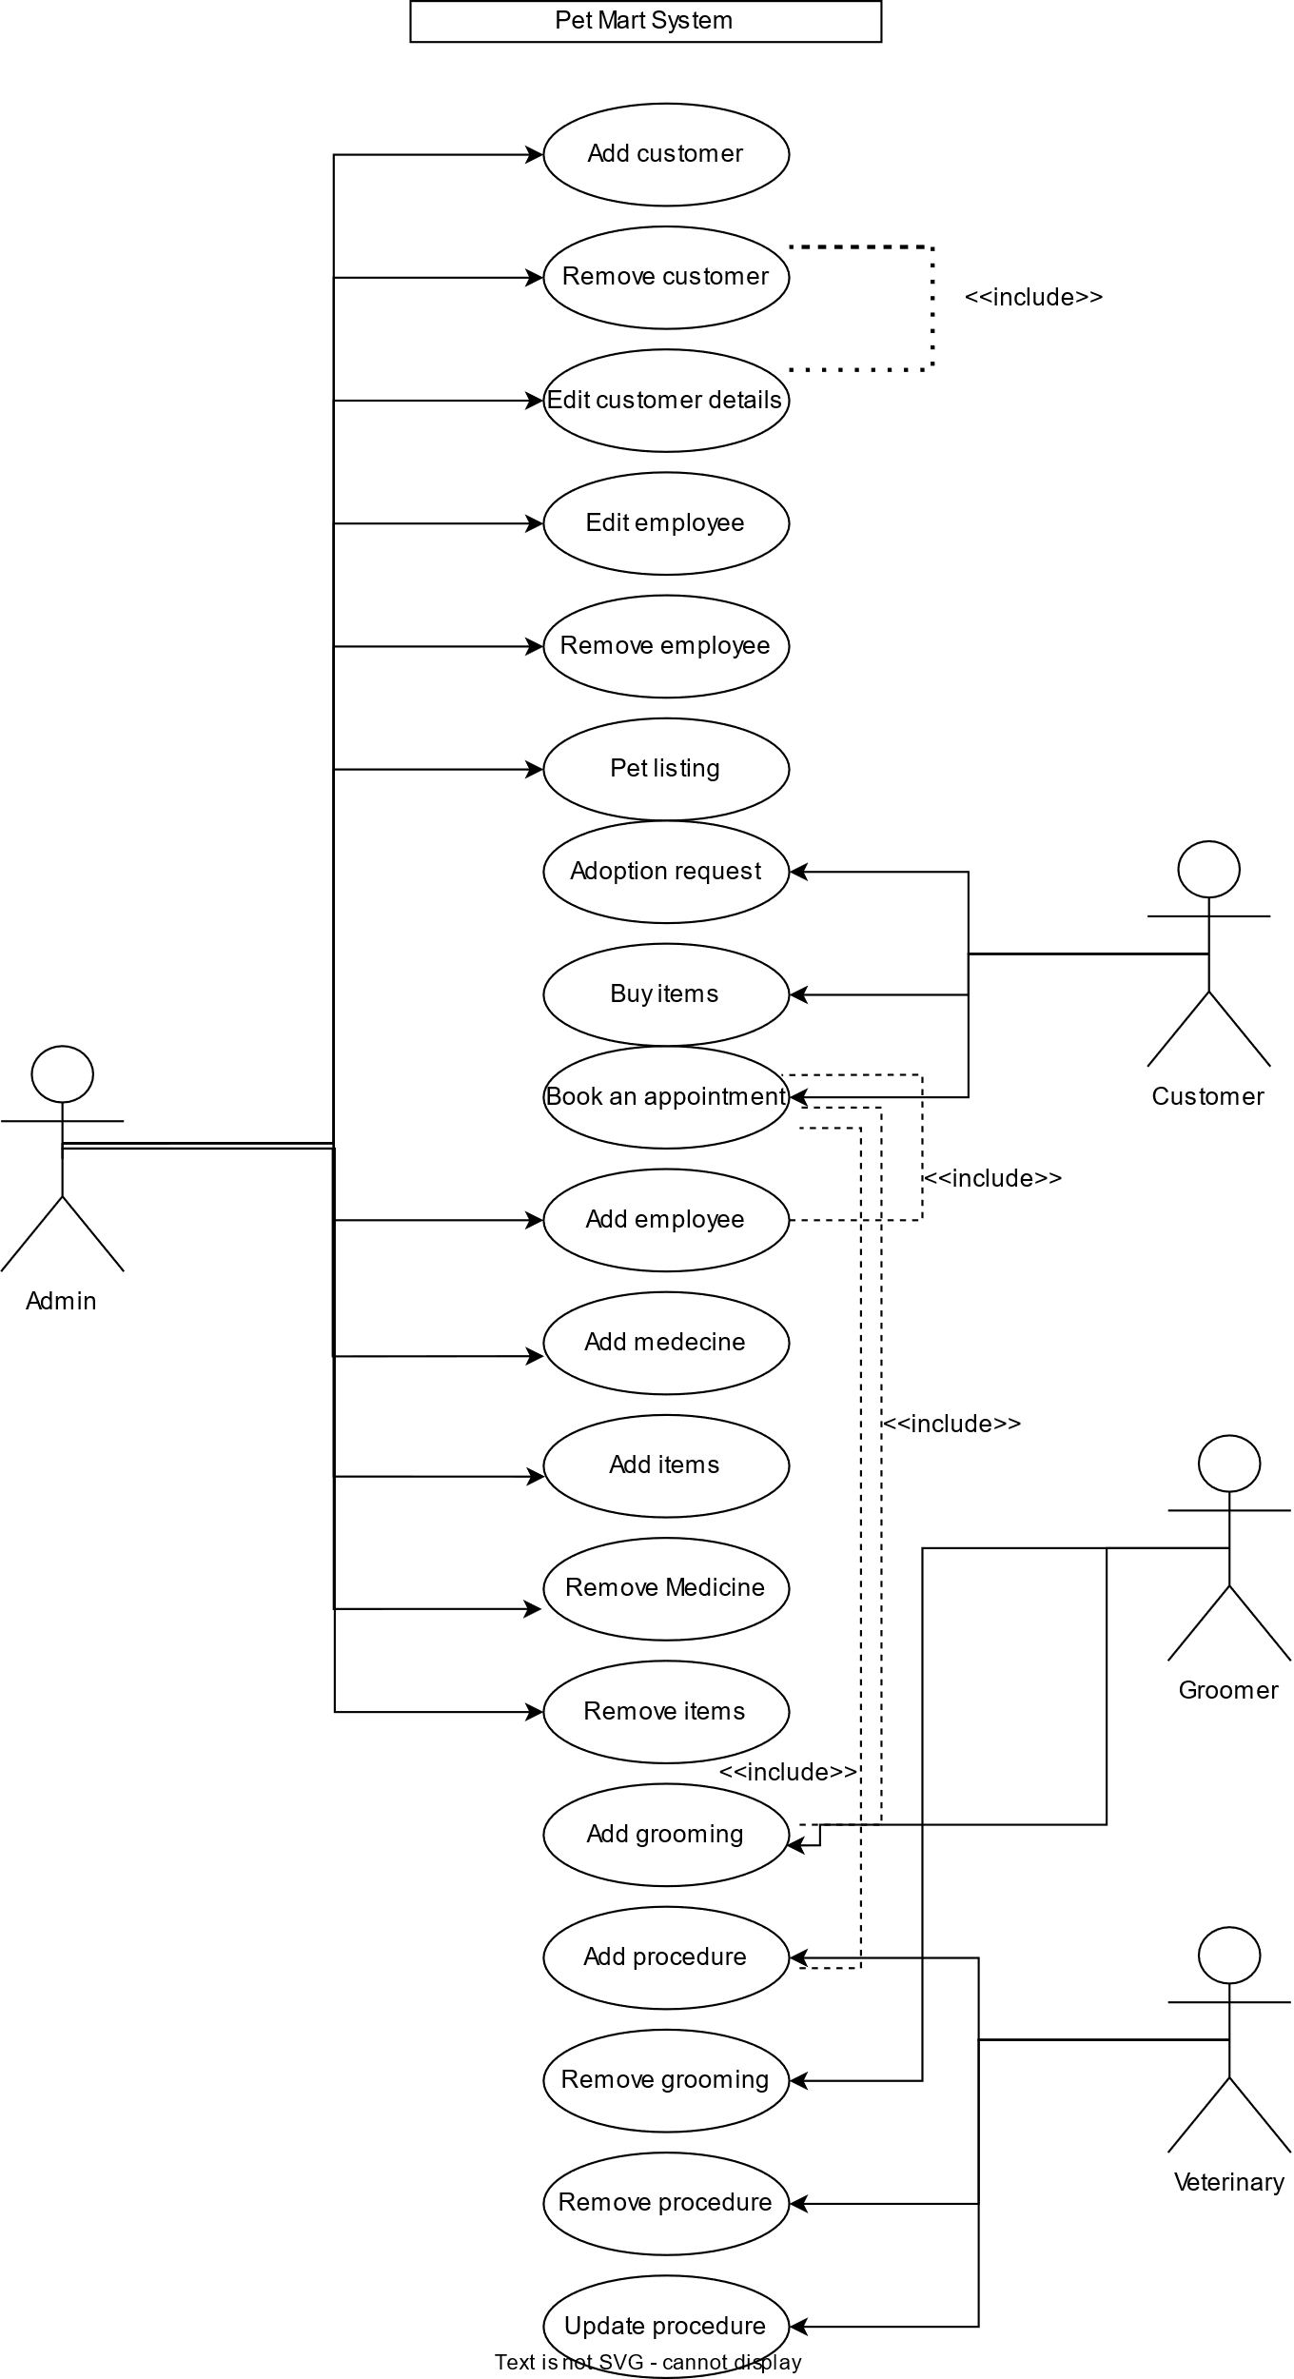

**Sequence Diagram:**

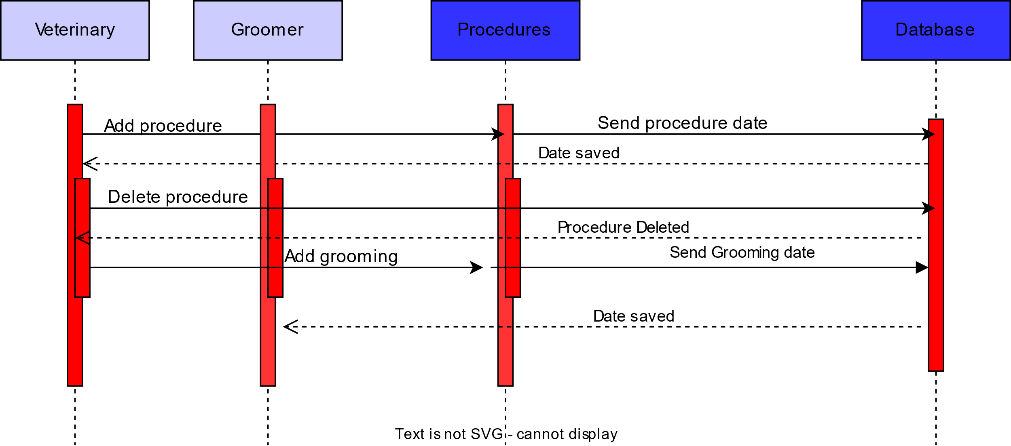

**Activity Diagram:**

Start

View Available Pet

End

Receive Pet

Sign Adoption Agreement

Interview

Application Review

Submit Application

Chose A Pet

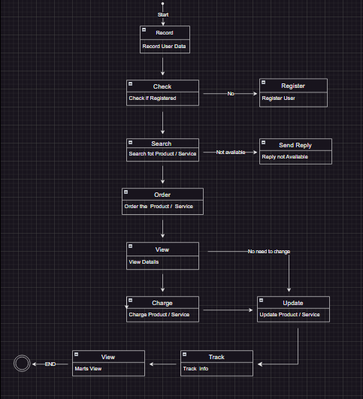**State Diagram:**

**EXERCISE -5: UI/UX Design:**

**UI/UX Design:**

**EXERCISE -6: Project Test Planning**

|  |  |
| --- | --- |
| Project Name: Pet Mart | Test Designed by: Mike |
| Test Case ID: #777 | Test Designed date: |
| Test Priority (Low, Medium, High): Medium | Test Executed by: Ajmayeen |
| Module Name: Login Session | Test Execution date: |
| Test Title: verify login with valid username and password | |
| Description: Test login page | |
| The precondition (If any): The user must have a valid username and password | |

|  |  |  |  |  |
| --- | --- | --- | --- | --- |
| Test steps | Test Data | Expected Results | Actual Results | Status (Pass/Fail) |
| 1. Goto application  2.Enter the username  3. Enter a password.  4. Click submit. | Username:  99999999999  Password: 443 | The user should log in to the application | As expected, | Pass |

|  |
| --- |
| Post Condition: The user is validated with the database and successfully logs in to the account. The account session details are logged in the database. |

|  |  |
| --- | --- |
| Project Name: Pet Mart | Test Designed by: Andrew |
| Test Case ID: #778 | Test Designed date: |
| Test Priority (Low, Medium, High): High | Test Executed by: Ajmayeen |
| Module Name: Detection | Test Execution date: |
| Test Title: First Product Detection | |
| Description: Test the AI for the detection | |
| The precondition (If any): Fulfill the credentials to help on detecting the Product | |

|  |  |  |  |  |
| --- | --- | --- | --- | --- |
| Test steps | Test Data | Expected Results | Actual Results | Status (Pass/Fail) |
| 1. Go to the application  2. Enter the category of animal  3. Enter the product name.  4. Click a suggestion | Username: 99, pass:4  Dog  Food | The user should find the desired product. | As expected, | Pass |

|  |
| --- |
| Post Condition: The user is validated with the database and successfully logs in to the account. The account session details are logged in the database. |

|  |  |
| --- | --- |
| Project Name: Pet Mart | Test Designed by: Tates |
| Test Case ID: #779 | Test Designed date: |
| Test Priority (Low, Medium, High): Medium | Test Executed by: Nafisa |
| Module Name: Detection | Test Execution date: |
| Test Title: Veterinary Service | |
| Description: Test the AI for the service detection | |
| The precondition (If any): Fulfill the credentials to help on detecting the service | |

|  |  |  |  |  |
| --- | --- | --- | --- | --- |
| Test steps | Test Data | Expected Results | Actual Results | Status (Pass/Fail) |
| 1. Go to the application  2. Enter the category of animal  3. Request for veterinary service.  4. Get recommendations | Username:44, pass:33  Cat  Veterinary | The user should get all the recommended available Vets | As expected, | Pass |

|  |
| --- |
| Post Condition: The user is validated with the database and successfully logs in to the account. The account session details are logged in the database. |

|  |  |
| --- | --- |
| Project Name: Pet Mart | Test Designed by: Mile |
| Test Case ID: #780 | Test Designed date: |
| Test Priority (Low, Medium, High): High | Test Executed by: Nafisa |
| Module Name: Cart | Test Execution date: |
| Test Title: Product Purchase | |
| Description: Test the AI for confirming purchases | |
| The precondition (If any): Fulfill the credentials to help on detecting the service | |

|  |  |  |  |  |
| --- | --- | --- | --- | --- |
| Test steps | Test Data | Expected Results | Actual Results | Status (Pass/Fail) |
| 1. Go to the application.  2. Select the items  3. Confirm Purchase  4. Get purchase confirmation and recite | Username:44, pass:33  Items  Verifies  Create recipe | The user should be able to purchase all the selected items | As expected, | Pass |

|  |
| --- |
| Post Condition: The user is validated with the database and successfully logs in to the account. The account session details are logged in the database. |

**EXERCISE -7: WBS and Effort Estimation**

**EXERCISE -8: Activity Scheduling and Resource Allocation**

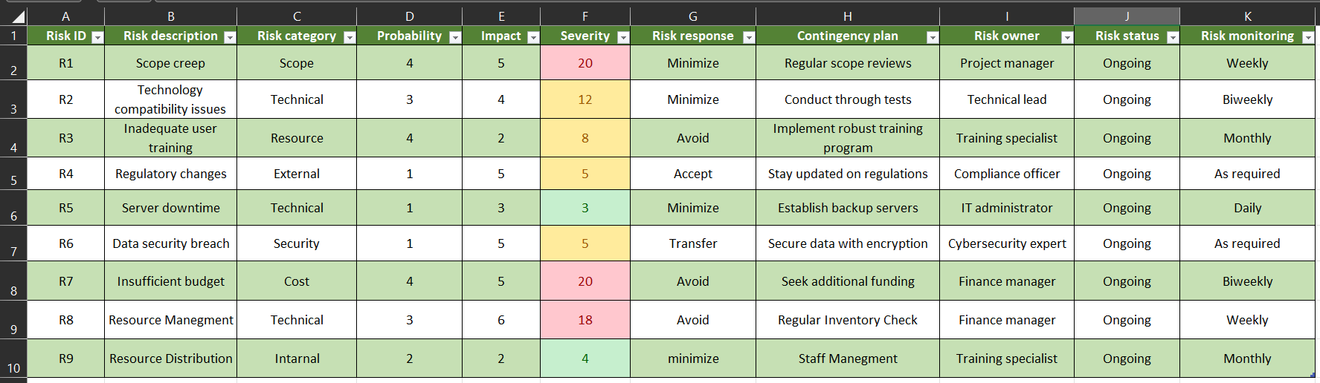**EXERCISE –9: Risk Analysis**

**EXERCISE –10: Progress of Project Execution**